Date: 29-12-2025 à Day 2 – Querying & Modifying Data
Create Sample Insurance database named InsuranceDB with tables, constraints, and initial sample data. Based on following er diagram and descriptions.
Entities we’ll model:
- Customers – people who buy insurance
- Policies – insurance products (Health, Motor, Life)
- Agents – insurance agents
- PolicyAssignments – which customer bought which policy
- Claims – claims raised against policies
Relationship Explanation
- One Customer → Many PolicyAssignments
- One Policy → Many PolicyAssignments
- One Agent → Many PolicyAssignments
- One PolicyAssignment → Many Claims

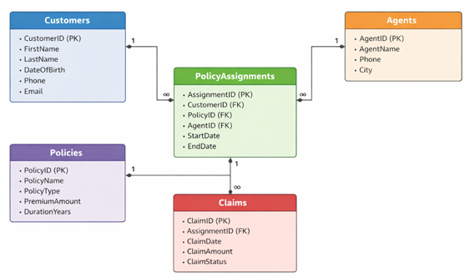
Submit following:
1. Create Database command.
2. Create table commands for all the tables with constraints, relationships etc.
3. Insert commands for all tables.
4. Select commands
- View all records Customers table.
- View all records of PolicyAssignment table with CustomerId, PolicyId, StartDate and EndDate columns only.
- Display all policies of Health type.
- Display policies having premium amount more than 10000 and DurationYears is 1.
- Display unique city names from where agents belong to.
- List policies of type Life, Health, Motor use OR clause.
- List policies of type Life, Health, Motor use IN operator.
- Display list of customers born after January 1st, 2001 and before December 31st, 2020 using >= and <= operators.
- Display list of customers born after January 1st, 2001 and before December 31st, 2020 using between operator.
- Display claims data where claim status is Rejected.
- Display records of Agents who stay in a city whose second letter is 'a'.
- Display highest and lowest claimAmount from Claims table.
- Display latest claim record.
- Increase premium amount to 10% for all health insurance policies.
- Delete the record of PolicyAssignments whose EndDate is before today's date.
- Display no of claims rejected.
- Display PolicyId, PolicyName, PremiumAmount along with computed fields not in table à 6% LocalTaxes, PremiumAmountWithTax and MonthlyPremiumAmount considering PremiumAmount is Annual.
- Write a command to add Address and City Columns in the Customers table.
- Write a command to add a new column named DevOfId (DevelopmentOfficerId) in an existing Agents table.
- Write command to make the above DevOfId as a recursive foreign key to AgentId as Parent.
5. Queries using Joins, Group By, Having etc.
- List all Policies for a CustomerId 5.
- View all customers with their policies.
- View claims with customer name.
- Display FirstName, PolicyName, AgentName, StartDate and EndDate from their respective tables.
- Display claims report with FirstName, PolicyName, ClaimAmount, ClaimStatus, and ClaimDate from their respective tables.
- Display records of Customers with or without Policies.
- Display all Customers with NO Claims.
- Show CustomerName with Total Claim Amount per Customer.
- Show names and total claim amount of Customers With Claim Amount > 50000 (Use HAVING Clause).
- Display list with Agent Wise Policy Count.

